A TECHNICAL REPORT ON STUDENTS INDUSTRIAL WORK EXPERIENCE SCHEME (SIWES)

HELD AT
AFABROS COMPUTER COLLEGE,
MUBI, ADAMAWA STATE

FROM: OCTOBER, 2023
TO: JANUARY, 2024

BY
DAUDA SUNDAY
(ST/CS/ND/22/019)

A SIWES REPORT SUBMITED TO THE DEPARTMENT OF COMPUTER SCIENCE, SCHOOL OF SCIENCE AND TECHNOLOGY FEDERAL POLYTECHNIC, MUBI, ADAMAWA STATE, NIGERIA
IN PARTIAL FUFILMENT OF THE REQUIREMENTS FOR THE AWARD OF NATIONAL DIPLOMA (ND) IN COMPUTER SCIENCE

MARCH, 2024

ATTESTATION
I Dauda Sunda hereby attest that I did my Industrial Attachment Program at Afabros Computer College, Mubi, Adamawa State between October, 2023, to January, 2024, and this report is prepared by me and submitted to the SIWES coordinator as required. I understand that all the information contained in this report are correct and will be penalized if found to be false. I also know that the SIWES coordinator may request for additional evidence as requested for reconciliation.

………………………………………… ………………………..
DAUDA SUNDA DATE
(ST/CS/ND/22/019)

CERTIFICATION
This is to certify that Dauda Sunday with a registration number ST/CS/ND/22/019 undergoes his industrial training SIWES at Afabros Computer College, Mubi, Adamawa State. In partial fulfillment of the requirements for the award of National Diploma (ND) in computer science, Federal Polytechnic, Mubi, as certified by the undersign officer.

Mr. Hyellamada Simon …………………………
DEPARTMENTAL SIWES CO-ORDINATOR DATE

DEDICATION
I dedicate this technical report to my lovely parents who gave me all the support and care throughout my SIWES program.

ACKNOWLEDGMENTS
I thank God Almighty for making me to undergo students industrial work experience scheme (SIWES) successfully.
My gratitude goes to my parent for their prayers, financial and moral support during my attachment.
I also appreciate the kind gesture of my brothers and sisters and those who supports me in prayers and contribution during my industrial attachment.
I whole heartedly thank my Head of department Mallam Kassim Mustapha, SIWES coordinator Mr. Hyellamada Simon and all lectures of Computer Science for their effort to ensure my success as their students.
I am greatly indebted to my co-SIWES students to mention, may God strengthen our relationship together and grant us academic excellence.
I sincerely thank you all for your contribution and support.

TABLE OF CONTENTS
Title Page - - - - - - - - - i
Attestation - - - - - - - - - ii
Certification - - - - - - - - - iii
Dedication - - - - - - - - - iv
Acknowledgements - - - - - - - - v
Table of contents - - - - - - - - vi

CHAPTER ONE: INTRODUCTION
1.1 Brief History of SIWES - - - - - - 1
1.2 Aims and Objectives of SIWES - - - - - 2
1.3 Roles of student - - - - - - - 2
1.4 Objectives of the report - - - - - - 2

CHAPTER TWO: HISTORY OF THE ORGANIZATION
2.1 Organizational chart - - - - - - - 3
2.2 Brief history of the organization - - - - - - 3

CHAPTER THREE: WORK EXPERIENCE I
3.1 Introduction to Microsoft Excel - - - - - - 6
3.2 Introduction to Microsoft Word - - - - - - 7
3.3 Introduction to Notepad - - - - - - - 9

CHAPTER FOUR: WORK EXPERIENCE II
4.1 Introduction to Internet - - - - - - - 11

CHAPTER FIVE: SUMMARY, CONCLUSION AND RECOMMENDATIONS
5.1 Summary - - - - - - - - - 13
5.2 Conclusion - - - - - - - - 13
5.3 Recommendation - - - - - - - - 13
Reference - - - - - - - - - 15

CHAPTER ONE: INTRODUCTION
1.1 BRIEF HISTORY OF SIWES
SIWES was founded in 1973 by ITF (Industrial Training Funds) to address the problem of tertiary institution graduates' lack of appropriate skills for employment in Nigerian industries. The Students' Industrial Work Experience Scheme (SIWES) was founded to be a skill training programme to help expose and prepare students of universities, Polytechnics and colleges of education for the industrial work situation to be met after graduation.
This system facilitates the transfer from the classroom to the workplace and aids in the application of knowledge. The program allows students to become acquainted with and exposed to the experience required in handling and operating equipment and machinery that are typically not available at their schools.
Prior to the establishment of this scheme, there was a rising concern and trend among industrialists that graduates from higher education institutions lacked appropriate practical experience for employment. Students who entered Nigerian universities to study science and technology were not previously trained in the practical aspects of their chosen fields. As a result of their lack of work experience, they had difficulty finding work.
As a result, employers believed that theoretical education in higher education was unresponsive to the needs of labor employers. Thousands of Nigerians faced this difficulty till 1973. The fund's main motivation for establishing and designing the scheme in 1973/74 was launched against this context.
The ITF (Industrial Training Fund) organization decided to aid all interested Nigerian students and created the SIWES program. The federal government officially approved and presented it in 1974. During its early years, the scheme was entirely supported by the ITF, but as the financial commitment became too much for the fund, it withdrew in 1978. The National Universities Commission (NUC) and the National Board for Technical Education (NBTE) were given control of the scheme by the federal government in 1979. The federal government handed over supervision and implementation of the scheme to ITF in November 1984. It was taken over by the Industrial Training Fund (ITF) in July 1985, with the federal government bearing entire responsibility for funding.

1.2 AIMS AND OBJECTIVES OF SIWES
The Industrial Training Fund’s Policy Document No. 1 of 1973 which established SIWES outlined the objectives of the scheme as:
- Provide an avenue for students in Institutions of higher learning to acquire industrial skills and experience in their respective courses of study.
- Prepare students for the Industrial Work situation they are likely to experience after graduation.
- Expose students to work methods and techniques of handling equipment and machinery that may not be available in their Institutions.
- Make the transition from school to the world of work easier; and enhance students’ networks for later job placements.
- Provide students with an opportunity to apply their knowledge to real work situations, thereby bridging the gap between theory and practice; and vi. Enlist and strengthen Employers’ involvement in the entire educational process; thereby preparing the students for employment in Industry and Commerce.

1.3 ROLES OF STUDENT
- Attend SIWES orientation programme before going on attachment.
- Comply with the establishment’s rule and regulation.
- Arrange living accommodation during the period of attachment.
- Record all training activity done and other assignment in the log book.
- Complete SPEI from ITF, FORM 8 and get it endorsed by the employer for submission to the ITF.

1.4 OBJECTIVES OF THE REPORT
The objectives of the SIWES report are;
- To make thorough explanation of the work done during my four-month industrial training.
- To fulfill the requirement for national diploma in computer science.
- To contribute to the body of knowledge and to enhance the understanding of the writer about a similar or same job.

CHAPTER TWO: HISTORY OF THE ORGANIZATION
2.0 DESCRIPTION OF AFABROS COMPUTER COLLEGE MUBI
Afabros Computer College Mubi is registered computer company incorporated under the companies and allied Matter Act 1990 with an RCR No. 012949 and CERT No. YLZ000304 and SERIAL NUMBER 1238084, and is wholly indigenous company. The company is multidisciplinary with specialization /bias in computer training (Engineering, repairs, software development, web design, networking), sales of computer, and secretarial service
VISION
To led in the provision of information technology and communication technology (ICT) service and specialization in the industrial and entrepreneurial graduate for development of the society.
MISSION
To build more proactive ICT company and offer an improved level of service to all clients.
To provide the best cost-effective service and solution
2.1 LOCATION AND BRIEF HISTORY OF AFABROS COMPUTER COLLEGE
Afabros Computer College is a private computer college, located in Mubi north local government of Adamawa state Nigeria. It was established in 2003 as computer center and was called “Afabros computers”, where people came to type, print and a few students for computer training.
The company laid emphasis on job quality, truthfulness, accountability, dynamism and satisfaction at all, time. As people that have vision, the staff spent most of their time in their office trying to finish all task to satisfy the needs of the students .beside the students and their sponsor are always satisfied with the outcome of the training. These gave the Afabros a good name which is the above every other name in computing, and now tagged,
“AFABROS was tried was tested, and now trusted”
The company which started with one personal computer, now has well over 50 working computer and three (3) department namely: computer/Electronics Engineering Department, computer science Department and a secretarial Department. Afabros Computer College has now graduated over 5000 students as of 2021. Students from college of Education, federal and state polytechnics, federal and state Universities all come to Afabros Computer College yearly for their student industrial working Experience Scheme (SIWES) programs. People from neighboring countries such as Republic of Chad and Cameroon are many in Afabros Computer College.
Afabros Computer College actively encourages entrepreneurship by his students. Most business-oriented graduates are now self-employed such as Start Best Computer Uba, Borno State, Celesmac Computer Federal Polytechnic Mubi signabobo company Ltd. (Njamena, Chad Republic), among others.
2.2 OBJECTIVE OF AFABROS COMPUTER COLLEGE TRAINING
Afabros Computer College has been producing majority middle-level manpower that has been making valuable contribution to the social and economic development of Africa and the world at large. The objective of the college are:
- To revolutionize the Afabros computer’s operation in line with dynamic of the operation environment
- To commit to operational excellence and long-term thinking thereby education students on computer usage
- To strengthen the Afabros brand, leverage and upscale the customers’ and students’ experience usage
- To project Afabros computer college as sophisticated and dynamic

HEAD
COMPUTER SCIENCE DEPEARTMENT
HEAD
SECRETARIAL DEPARTMENT
LABORATORY ATTENDENT

PRODUCTION MANAGER
HEAD
ENGINEERING DEPARTMENT

COMPUTOR OPERATOR

CLEANER
SECURITY
SE
POWER MANAGER
ACADEMICE SECRETARY
DIRECTOR OF STUDENT
ORGANIZATIONAL CHART AFABROS COMPUTER COLLEGE MUBI

SIWES COORDINATOR

CHAPTER THREE: WORK EXPERIENCE I
3.1 MICROSOFT EXCEL
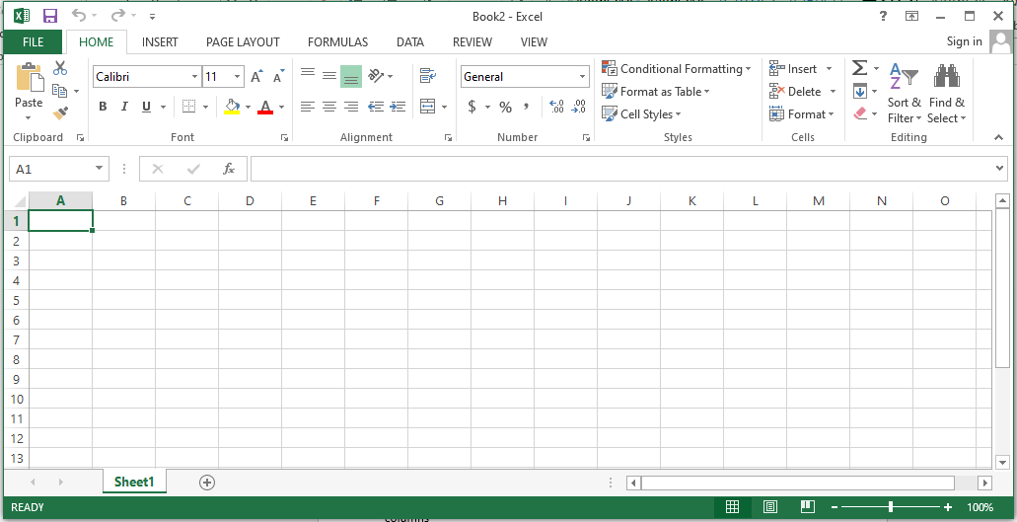
Figure 3.1: Microsoft excel 2013 interface
Definition of Microsoft excel: this spreadsheet that manipulate date in row and columns
ROW: this run from left to right across the window and it position is designated by numbers
FILL HANDLE: a small back square at the lower corner of the selected cell
NAME BOX: this display the name of the selected cell or range cell

SOME BASIC OPERTATION SIGNS THAT ARE USED IN MICROSOFT EXCEL AND HOW THERE ARE USE:
- equality sign =
- exponent sing ^
- Division /
- additiion +
- subtraction -
HOW TO CACULATE SUM
We use sum when calculating addition in excel. And before spreadsheet can respond to any mathematical command. It must be entered as an equation. Therefore, to enter a function as an equation. We must firstly start with ‘‘equals to’’ (=) sign.
Steps in calculating sum:
- Firstly, the data must be entered correctly as shown below
- Then keep your cursor on the location you want sum to be displayed by clicking the mouse there
- Type =sum and open bracket ‘‘(then, click the mouse on the first cell you want to sum now type : click mouse on the last cell containing the data to be sum
- Then close the bracket )
- Press enter on the keyboard.

EXAMPLE
I learnt how in insert pie in micro soft excel
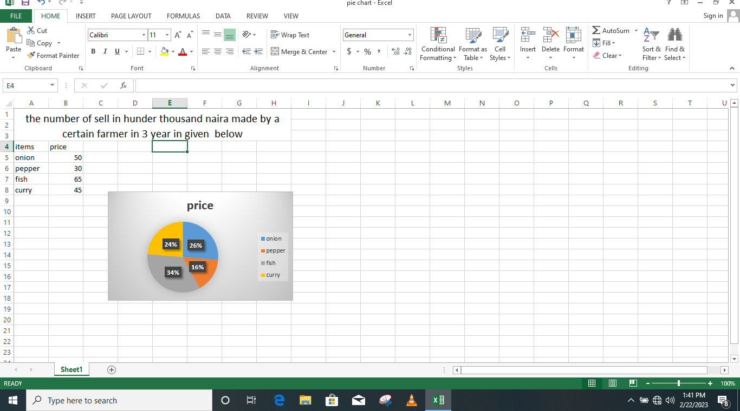
3.2 MICROSOFT WORD
Microsoft is an application package that allows one to type, edit and retrieve a typed document. It is used to create beautiful document, typing of letters time tables, design report form and insertion of image to a document you have typed.
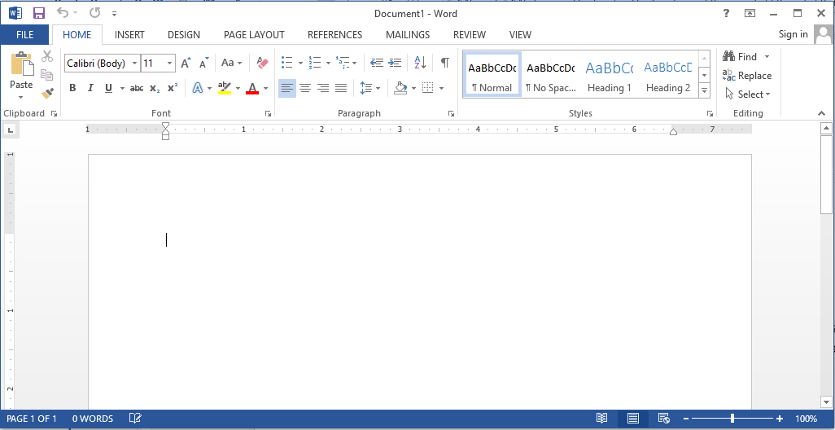
Figure 3.2: Microsoft word interface

KEYBOARD SHORTCUT IN MIRCOSOFT WORD
The keyboard shortcut keys are:
Control +A =select all
Control+ B = turn bold on or off
Control + C = copy selected object
Control + D = duplicate selected object
Control + E = center alignment of a selected paragraph
Control + F = find missing or hidden text
Control + G = go to specific page
Control + H = find and replace missing text or hidden text
Control + I = italicize selected text
Control + J = justify selected paragraph
Control + K =insert hyperlink
Control + L = left align of a selected paragraph
Control + M = left indent
Control + N = new blank document
Control + O =
Control + P = print dialog box
Control + Q = format paragraph
Control + R = right align of selected paragraph
Control + S = save dialog box
Control + T = hang intent
Control + U = under line selected paragraph
Control + V = past object after begin copied or cut
Control + W = close a file especially in Microsoft word
Control + X = cut selected text or object
Control + Y = redo last action
Control+ Y = undo last action
3.2.1 HOW TO SAVE A FILE AS PDF IN MICROSOFT WORD
Step1: open the file
Step2: click file on the menu bar
Step3: click save as
Step4: below the file name you will see
Step5: save as type
Step6: select PDF
Step7: save
3.3 NOTEPAD
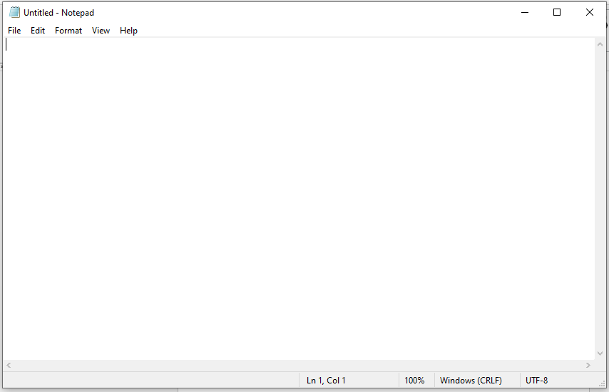
Figure 3.3: Notepad interface
3.2.1 HOW TO LAUNCH A NOTEPAD AND HOW TO CREAT A SIMPLE TABLE
Start
All programs
Accessories
Notepad
Then Type the following:
<html>
<table border=1>
<td>serial number</td>
<td>name</td>
<td>registration number</td>
<td>course of study</td>
<tr>
<td>1</td>
<td> Hosea victor </td>
<td>ST/CS/ND/22/140</td>
<td>computer science </td>
<tr>
<td>2</td>
<td>Alhamdu Musa</td>
<td>ST/CS/ND/22/124</td>
<td>computer science </td>
<tr>
<td>3</td>
<td>Emmanuel Levi</td>
<td>ST/CS/ND/22/143</td>
<td>computer science</td>
<tr>
<td>4</td>
<td>Isaac Moses</td>
<td>ST/CS/ND/22/002</td>
<td>computer science </td>
<tr>
<td>5</td>
<td>Emmanuel James</td>
<td>ST/CS/ND/22/140</td>
<td>computer science</td>
<tr>
<td>6</td>
<td>Buhari Musa</td>
<td>ST/CS/ND/22/002</td>
<td>computer science </td>
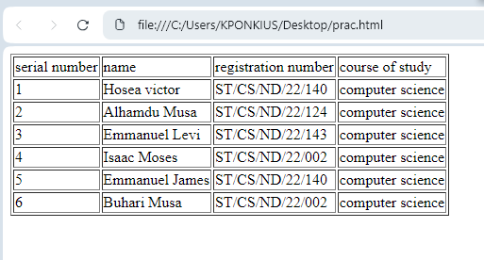
3.3.2 THE MEANING OF SOME HTML TAGS
<Opening tag
>closing tag
<br>break a line</br>
<b> to make bold</b>
<u> to underline</u>
CHAPTER FOUR: WORK EXPERIENCE II
4.1 THE INTERNET
Internet is the global networks of computers. On the internet, millions of computer are connected together so that the could share files and information. You can link your computer to the internet anywhere you are in the world through any of the following items:
Dial up connection:- this dial up connection is the slowest means of accessing internet. Example of dial up connection is through telephone cable. If you use the dial up connection, you cannot connect to the internet and talk on the internet at the same time. Unless you have a second phone line.
- ISDN (integrated service ditital network):- is a telephone line which carries digital signal at higher speed than Dial-up connection. CD-Audio quality sound and superior video conferencing images coluld be transmitted through ISDN. It requires a telephone company to install the connectors.
- DSL (Digital Subscriber Line):- also uses the existing telephone lines but the signal is split at the entry point to the home or office building,so DSL coming into the computer doesn’t share the regular phone line connection to use DSL you must located within 20,000 feet of the telephone switching station ,,, ssso DSL is most common in the urban area
- Cable : csble connection to the internet require using a television cable systems
- Satellite : in remote place where DSL or cable is not possible , you can use the satellite connection to internet. A small satellite dish at your home sends the signal to the satellite that bounces the signal to another dish at your service provider network center
- TI: TI line and the faster T3 lines use high speed dedicate phone trunk line that would normaly carry multiple telephone line. They are generally usaed by the government agencies , cooperatives and educational institution that have many user connecting at one time
There is confusion between internet and World Wide Web (3w or www) internet is the HARDWARE that connect the computer network world wide . ythe internet server as a pipeline for FTP ( file transfer protocol), electronic mail, useNet news the,and www etc . how ever www is service which easy access to the internet’s wealth of information.its primary function is to connect, link and related information.
Web page is a page you read on the internet using a web browser. Web page can contain text , graphics, animation , video and sound Web page can include dyamic element which change or update continually. Web page can contain hyperlinkers. Web sit is 2 or more related web pages.portal site is a web site which offers a varity of service , include searching capabilities . portal site allow you to choose what is display on the page , giving a dynamic personalized feel to the site. For this reason , many people will chose a portal site as their home page . Every time they lunch their browser , they willsee all the lastest information customized to their preferences. Exmple of portal site are :Yahoo, www.yahoo.com, google ,www.google.com,Microsoft , www.microsoft.com etc
HOW TO DOWNLOAD A FILE FROM INTERNET
- Click start on the taskbar
- Click google Chrome (or the installed browser)
- On the address bar , type the criteria , e.g how to locate ground water , and press Enter on the keyboard.,
HOW TO SEND ATTACHMENT
The steps are :
- Log into your account
- Click on cpmpose
- Write to
- Subject
- Write what you want to send to the person
- Click attache file
- It open the folder &select the file you want
- Click send and finally
- enter

CHAPTER FIVE: SUMMARY, CONCLUSION AND RECOMMENDATIONS

5.1 SUMMARY
The relevance of the SIWES program cannot be over emphasized considering the fact that it has significantly reduced the gap between my theoretical and practical knowledge about computer hardware and software, installations, maintenance and networking. The processes of communication which include data and telecommunication the use of switch in the networking and what networking is all about.
The program is indeed a commendable one in that it affords students ample opportunities of being exposed to good working relationship with colleagues and the field experience with customers. This little exposure has widened my knowledge about my course of study, not only that it has automatically changed my views about lift in general. The firm at large has taught me how to be independent of my own how to be conscious of my health and safety at its peak relating to the environment where I carried out my SIWES program. It was indeed a highly rewarding experience to be with Afabros Computer College, Mubi, Adamawa State.
5.2 CONCLUSION
In conclusion, I thank ITF in general for their effort towards the Student Industrial Training Scheme. The contribution that the industrial training offered to student will not be over emphasized. It has exposed me seriously to a certain depth and length of practical capability on Web Designs.
It has also acquainted me with the working condition, which I am expected to encounter in the near future. I will say that SIWES has a greater advantage on me, it has greatly exposed me to the practical application of all that I have been through in the school, SIWES is an experience that all student must pass through this is because it gives a full practical knowledge of what has been through in classroom.
Finally, I have a strong believe that this comprehensive based on the experience, I acquired during the industrial training scheme will convince every user training is not difficult.
I therefore strong conclude that the continuous existence of SIWES programme as it is very necessary since it plays a dominant role in the development of student of Computer Science in the acquisition of practical experience.
5.3 RECOMMENDATIONS
Below are the recommendations that should be given serious consideration so as alleviate the suffering of students undergoing SIWES.
Firstly, the Federal Government of Nigerian should make a positive effort in reducing the overall cost of production so that companies should be producing to fill capacity and accommodate SIWES populaces. Also, certain monthly allowance may be given to the student by company accepted then (student to ease transportation problem).
Secondly, the Industrial Training Fund (ITF), should try and increase the money paid at the end of SIWES to the student so as to justify the Cost of Living we experienced.
Thirdly, the period set for the SIWES should be increase to six mouths so as to enable the student involved and gain enough experience since it is widely believed that experience is the best teacher. Again, this period should also be in line with Nigerian University Commission curriculum for the university undergraduate student on industrial attachment.
Finally, the ITF official should please continue visiting the students, to ensure that what they are learning is in line with the ITF requirement.

REFERENCE
Edward, B. (2003). The Effect of SIWES on a student, Federal Ministry of Works, Lagos. Nigeria.
John, Doe (2008). Introduction to web development: responsive designs, McGraw Print New York.
Samuel, J. (2017). Visual Basic (VB) Tutorial Overview. Retrieved 25 July, 2022 from www.tutlane.com/tutorial/visual-basic

